Advanced Neuroscience HW7

Aliakbar Mahmoodzadeh 98106904

1. **Question 1**

simple_model.m function simulates the drift-diffusion model. It is in function folder.

The output is shown in this part: 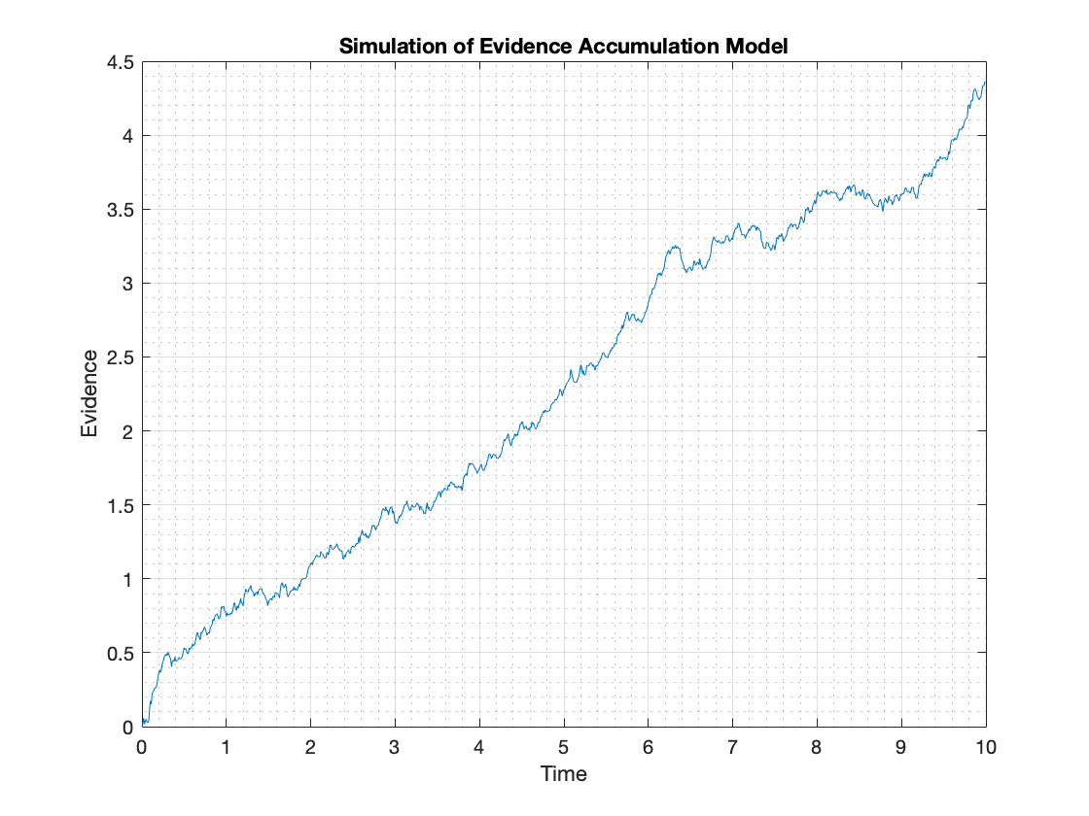

1. **Question 2**

To find the distribution of choices, first distribution of x must be found. Choice is a binary variable that can be -1 and 1:

$$\begin{matrix}x(t+dt)=x(t)+dt×B+σ×dW \\ x(T)=x(0)+\sum_{i=1}{ } Bdt+σdW(i)=BT+σ\sum_{i=1}{ } dW(i)\end{matrix}$$

$$\begin{matrix}E[x(t)]=E[BT]+σ\sum_{i=1}{ } E[dW(i)]=BT, σ_{x}^{2}=var⁡(BT)+σ\sum_{i=1}{ } var⁡[dW(i)]=σT \\ \\ P(\text{ choice }=1)=P(x(t)>0)=\int_{0}^{∞}{ } \frac{1}{\sqrt{2πσT}}exp⁡\left(-\frac{(t-BT)^{2}}{2σ^{2}T^{2}}\right)dt\end{matrix}$$

$$x(t)∼N(BT,σT)$$

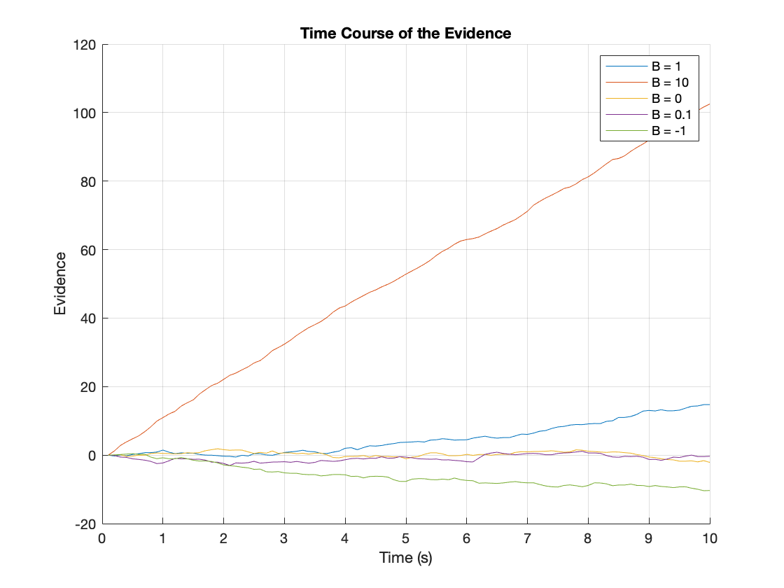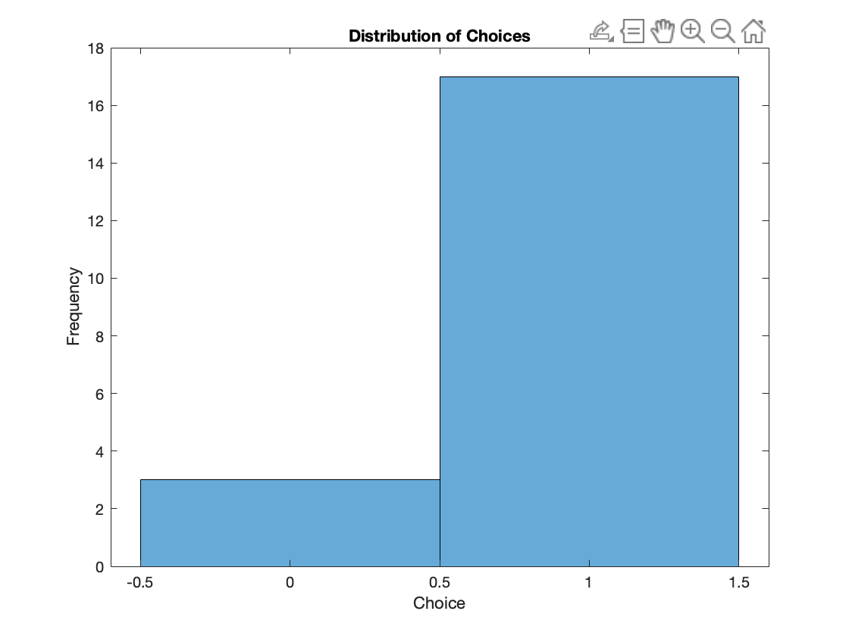And this is the result:

1. **Question 3**

This probability is calculated theoretically:

$$P_{\text{error }}=∫_{0}^{∞} \frac{1}{\sqrt{2}πσT}exp⁡\left(-\frac{(t-BT)^{2}}{2σ^{2}T^{2}}\right)dt$$

This is the result:

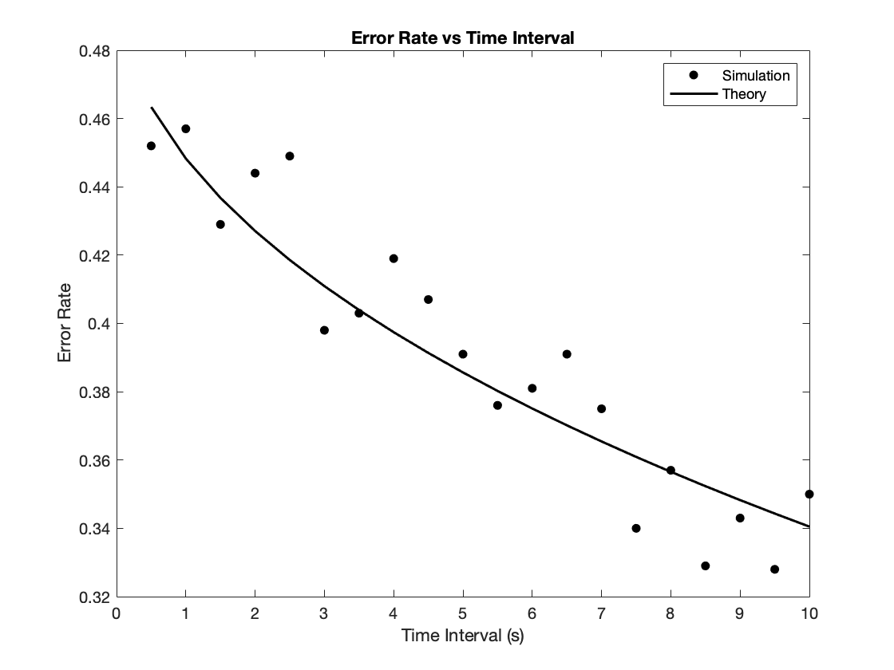

1. **Question 4**

𝐸[𝑥(𝑡)] = 𝐵𝑡  
𝑣𝑎𝑟(𝑥(𝑡)) = 𝜎𝑡 so we have: 𝑠𝑡𝑑(𝑥(𝑡)) = √𝜎𝑡

And this is the result:

Some evidence plotted: 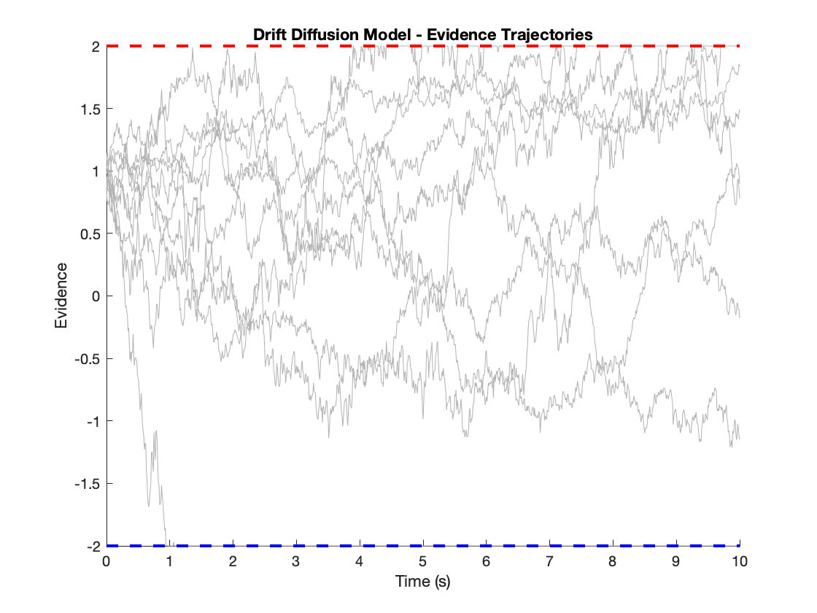

And this is the complete version of the plot with mean and std: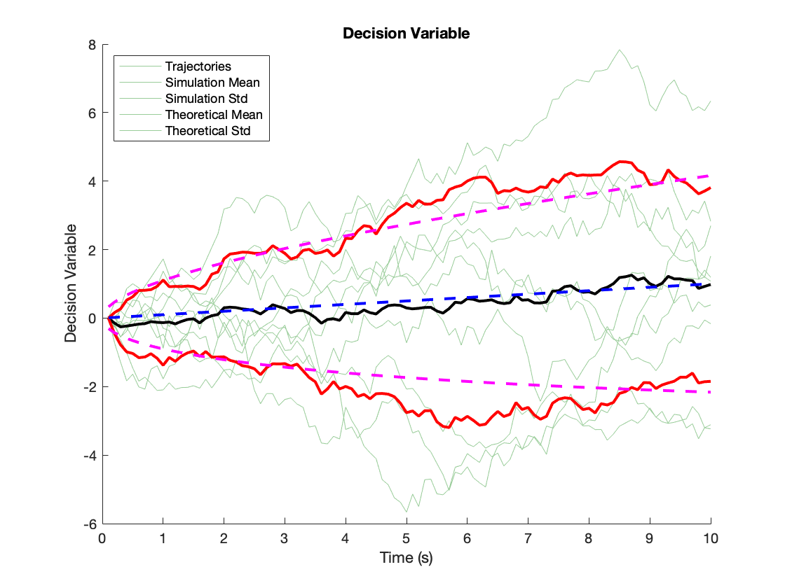

1. **Question 5**

I changed starting point from 0 to 1 and calculate the CDF of X and this is the result:

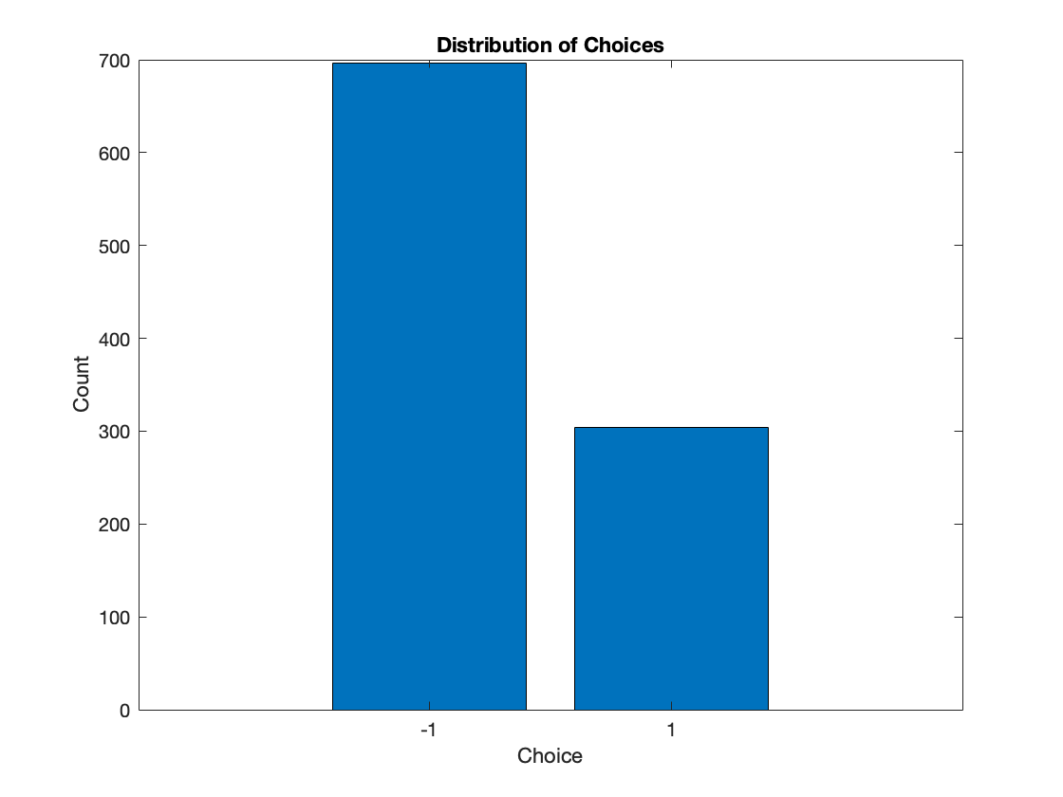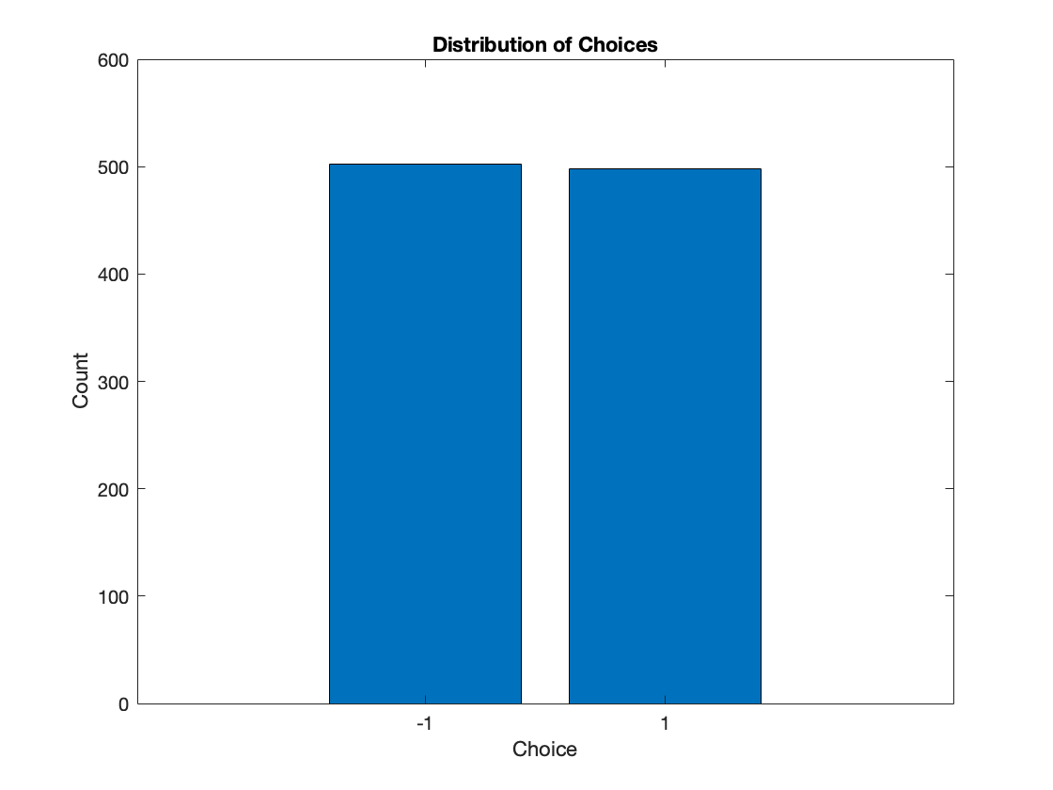Starting point = [0, 0.5, 1]

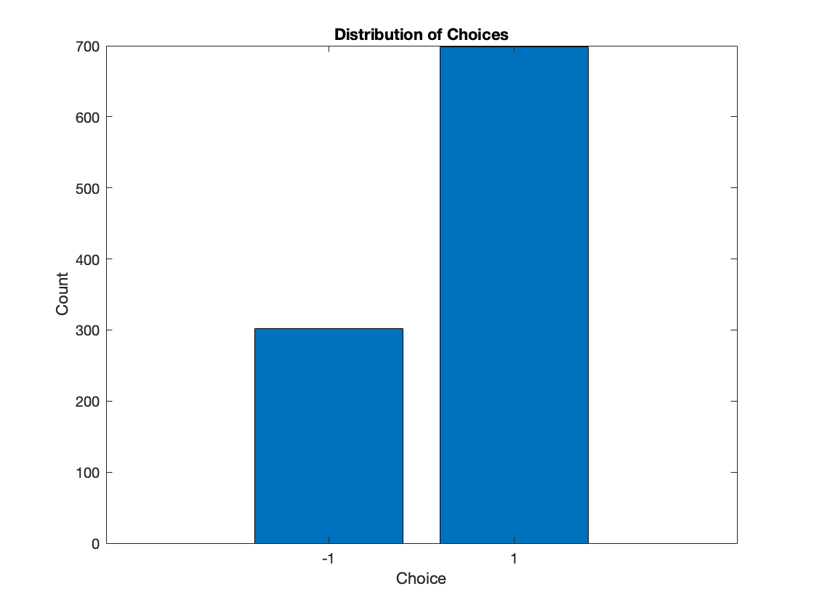

1. **Question 6**

This code generates a drift diffusion process with a start point of 1 and positive and negative thresholds set at 2 and -2, respectively. The evidence variable **x** accumulates over time based on a bias term, noise, and time step size. The plot shows the evidence trajectory over time, along with the positive and negative thresholds as dashed lines.

trajectory over time: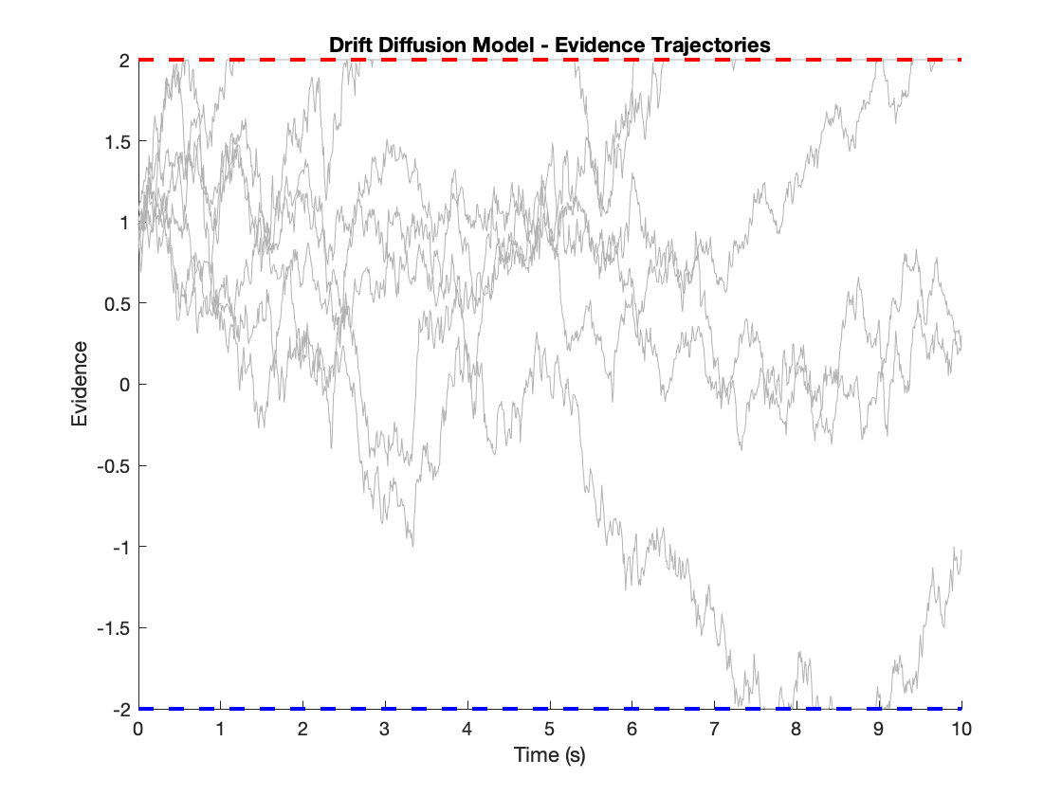

Tow choice trial implementation: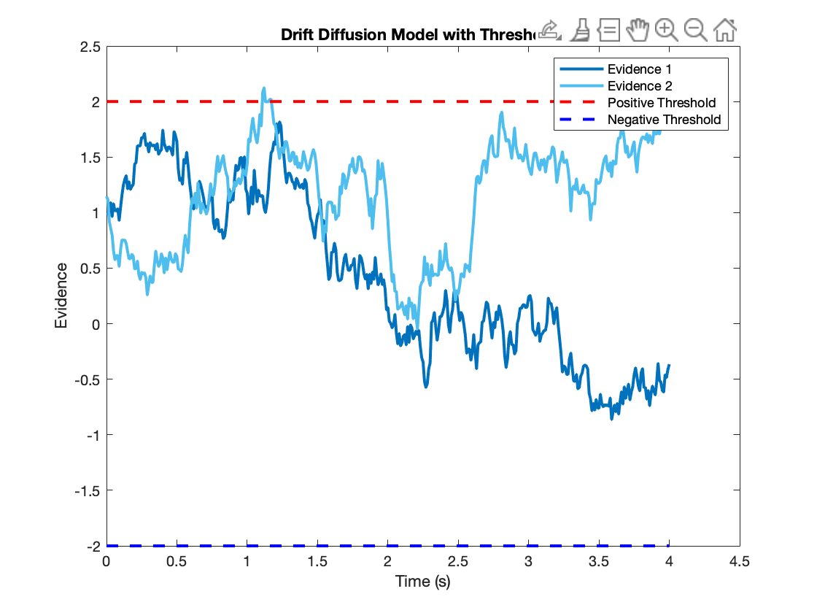

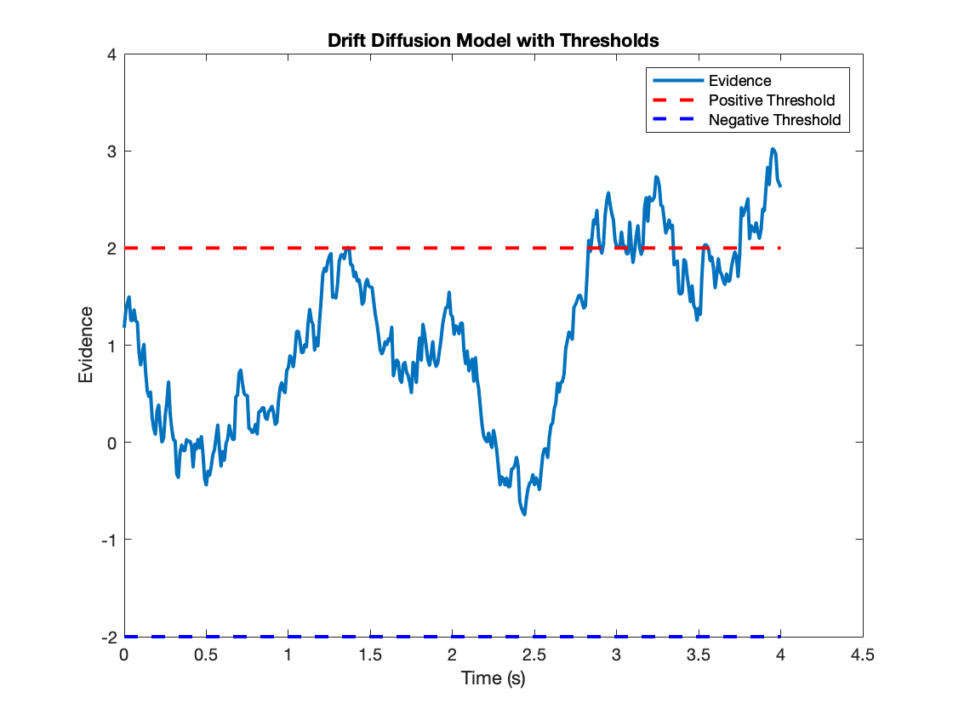

1. **Question 7 and 8**

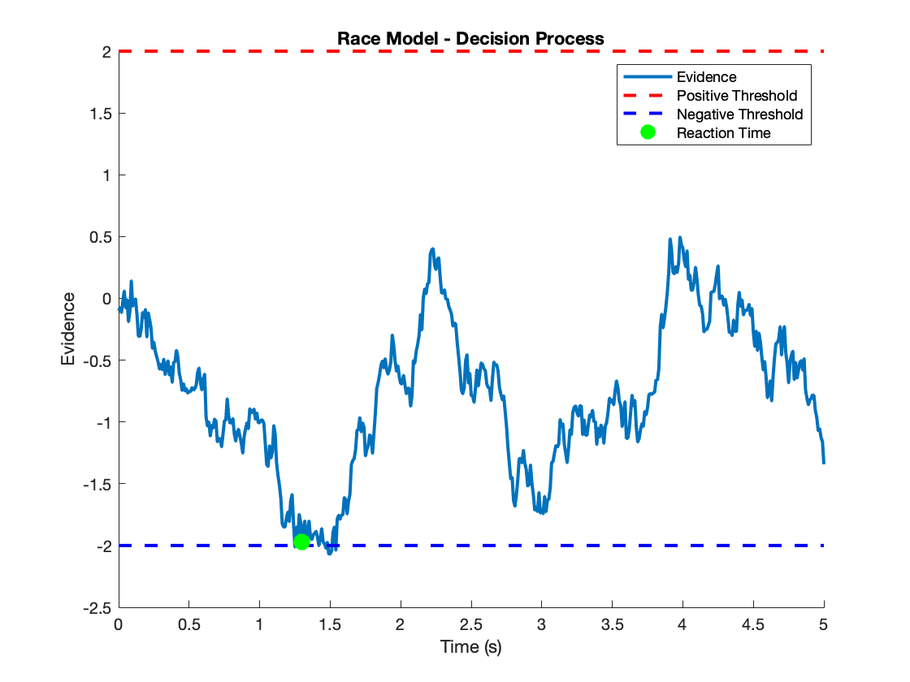

**PART 2:**

**Question 1:**

the code simulates the interaction between the MT1, MT2, and LIP neurons and demonstrates how the firing rates of MT1 and MT2 affect the firing of the LIP neuron.

during the initial milliseconds, as a result, the LIP neuron does not fire during this time period.

Eventually, the excitation becomes strong enough to overcome the inhibition, and at that point, the LIP neuron starts firing. This firing of the LIP neuron represents a decision being made by the system.

And this is the result: 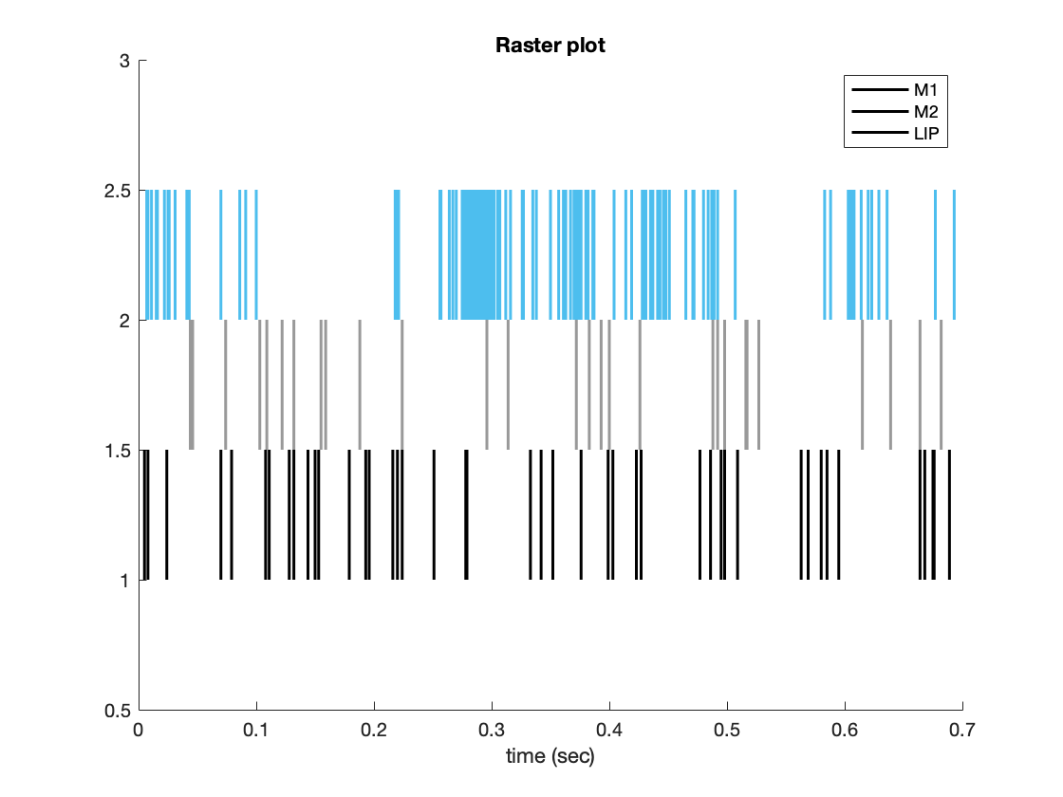

**Question 2:**

When MT1 is more active, meaning it has a higher level of activity or firing rate, it leads to the activation of LIP1. This activation is indicated by the presence of spikes or events in the activity of LIP1.

On the other hand, when MT2 is more active, meaning it has a higher firing rate compared to MT1, it leads to the activation of LIP2. This activation is indicated by the presence of spikes or events in the activity of LIP2.

In simple terms, the simulation shows that the activity of the LIP neurons (LIP1 and LIP2) depends on the relative activity levels of the input signals (MT1 and MT2)

This is the result:

